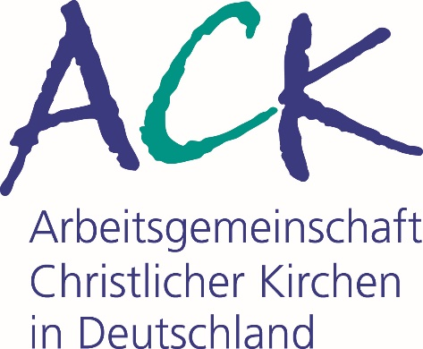
Worship Booklet for the Ecumenical Day of Creation 2022
God's love reconciles and unites the suffering creation 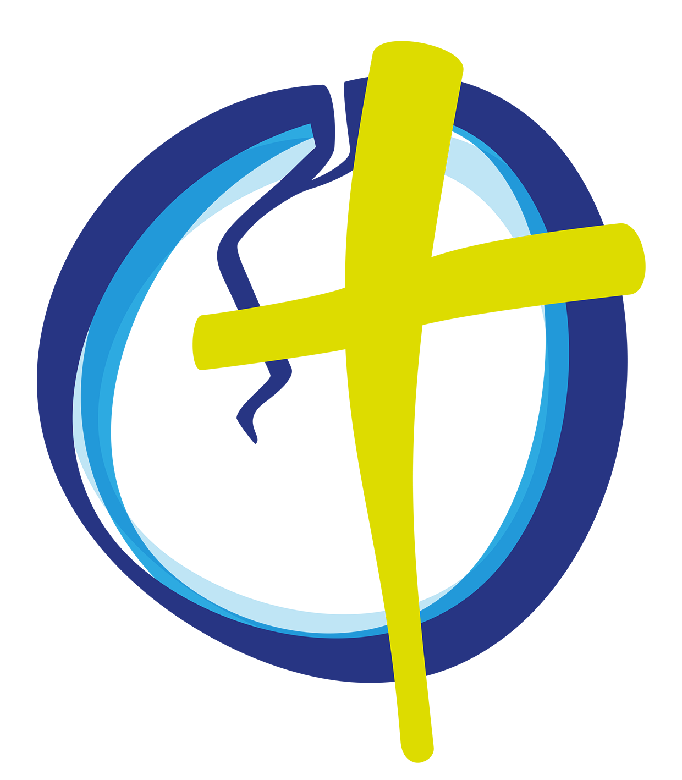
www.schoepfungstag.info

Content

Content 2
Foreword 3
God's love reconciles and unites the suffering creation. On this year's central celebration of the Day of Creation in Karlsruhe 5
Abbreviations 7
Worship Service of the ACK for the Ecumenical Day of Creation on 1 September 2022 8
Further links 18
Imprint 19

We would like to publish as many dates and events as possible for the Ecumenical Day of Creation at www.schoepfungstag.info. We kindly ask you to send us dates and information about worship services and events to info@ack-oec.de.
Thank you very much!
Your Ecumenical Centre

Foreword
A few days ago, at the school where I teach Orthodox religion, I found a sentence in an essay written by a pupil whose mother tongue is admittedly not German. The sentence made me smile, but it also gave me pause for thought. The girl had confused the German words “schöpfen” (create) and “erschöpfen” (exhaust), so that her sentence translates: "God exhausted man". I was once again reminded of the difficulties of our language and of the way in which tiny differences – in this case just a couple of letters – can be very important. They can even change “creation” into “exhaustion”.
The expression "creation" is naturally at the centre of the "World Day of Prayer for the Care of Creation", which will be celebrated centrally this year on 1 September 2022. For the Council of Churches in Germany (ACK), it is the conclusion and climax of the "Year of Ecumenism 2021/2022", which was intended to present and advance in numerous ways multilateral ecumenism as a project and vision. This celebration, which this year coincides with the beginning of the Orthodox Church Year – as was originally intended –, falls within the session of the Assembly of the World Council of Churches (WCC) in Karlsruhe. This Assembly was delayed for one year due to the pandemic and is scheduled to be held in the fan-shaped city from 31 August to 8 September 2022. Every year since we established the Ecumenical Day of Creation in Germany, it was our intention to demonstrate our common commitment and solidarity with the worldwide ecumenical movement, and this will be particularly evident this time in Karlsruhe. Delegates from all corners of the earth will gather together in Karlsruhe to experience the Ecumenical Day of Creation of the ACK as a tried and tested example of ecumenism in our country. To quote the vocabulary used by the ecumenical movement based in Geneva, one may well speak of a best practice example...
This year's theme for the Day of Creation is "God's love reconciles and unites the suffering creation", based on the theme proposed by the WCC for this day: "The purpose of God's love in Christ for the whole creation – reconciliation and unity". It is a very "theological" motto, covering not only the reconciliation of Christians with each other but also their reconciliation with the Creator, and reconciliation in creation. For some ecological activists it may even sound "too theological". But there is no way around it: for us as members of our churches, it is this faith in the Creator God that must primarily be rediscovered if our commitment to his good creation is to be soundly based and effective.
I offer my sincere thanks to all who helped to prepare this day and its celebration in Karlsruhe and throughout Germany, to those who conceived and edited this booklet – first and foremost at the Ecumenical Centre in Frankfurt with their expertise and excellent work – but especially to all who will hold services for the Day of Creation in their congregations. With gratitude I pass on this publication to you, dear readers, hoping that it will bring widespread blessing.
In conclusion, however, I must make one comment to my pupil who produced the lapsus linguae mentioned at the beginning. I believe it is we who have “exhausted” our Creator through our treatment of creation... The Day of Creation is indeed an occasion which was created to let us think about this – creatively!

Archpriest Radu Constantin Miron
Chairman of the ACK in Germany

God's love reconciles and unites the suffering creation.
On this year's central celebration of the Day of Creation in Karlsruhe

Very many hopes rest on the preparation for the central service on the Ecumenical Day of Prayer for the Care of Creation 2022 in Karlsruhe, as on the preparation for the Assembly of the World Council of Churches in the city between the Black Forest and the Rhine. At last we can come together again after all the months in which the pandemic forced us to keep our distance. We will celebrate church services in large numbers. We hope to experience reconciliation personally in churches and between nations, across borders and continents.
The Day of Creation explicitly takes up the call for reconciliation, and above all our longing for reconciliation. It takes it up with heartfelt confidence that the biblical God wants to give us his reconciliation and offers it to us. Reconciliation with himself that overcomes all separation. Reconciliation between people who have become alienated from one another. Reconciliation in creation and with it.

In his letter to the church in Rome (Romans 8:18-39), Paul describes the suffering of creation. He writes of its groaning, its pain, and expresses in striking words how God's creation has been put into bondage, deprived of its freedom, and is therefore dependent on liberation, on redemption.
The motto of the Day of Creation 2022 reminds us that the many cracks and tensions in creation belong to our experience as humanity – some of them coming from natural causes, others from human hands. The motto reminds us that creation itself is also involved in the struggle for resources, for access to clean water, unpolluted air, or nutrients. It is by no means a harmonious unity. This rift also runs right through humanity as a species. Humanity is not united in its needs and wants. And there are gaping wounds between humans and their environment, even more so between humans and wild nature.
How great is the hope that reconciliation and unity are a central concern of God. How great is our mutual expectation from each other that we should follow in the footsteps of the biblical God and do all in our power to work towards reconciliation, compensation and justice for and with all creation.

The Christian confession includes the belief that God made himself part of his creation. That he did not keep his distance from creation, but rather entered into creation bodily. God's creative, life-giving Word became flesh and – according to Scripture – exposed himself to the broken, painful, suffering creation.

We can remind ourselves once again of this, confessing to one another God’s solidarity with his creation as well as his friendship and love for his creatures and all things he has created. We are invited to do so – in Karlsruhe, too. The Christian churches of Karlsruhe are happy to be your hosts.

Pastor Kira Busch-Wagner
Chairwoman of the ACK in Karlsruhe

Abbreviations
BG Hymnal of the Moravian Brethren in Germany, 2007
CoG Colours of Grace, Hymnal of the Communion of Protestant Churches in Europe, 2007
EG Evangelisches Gesangbuch, Hymnal of the Evangelical Church in Germany, 1995
C Congregation
GL Gotteslob, Hymnal of the Roman Catholic Church in Germany, 2013
M Minister
NL Wo wir dich loben, wachsen neue Lieder, Appendix to the EG in Baden, the Palatinate and Württemberg, 2018
ThM Thuma Mina. International Ecumenical Songbook, 1995

Worship Service of the ACK for the
Ecumenical Day of Creation on 1 September 2022

Instrumental music

Entrance

Hymn "Singt dem Herrn, nah und fern" (BG 1036,1.2)
or
"In Christ there is no east or west" (CoG 76, German, English, Dutch, Norwegian;
NL 160 German, English, French).

Liturgical greeting and opening
The congregation responds with the chorus: "Atme in uns, Heiliger Geist (Breathe in us, Holy Spirit)” (GL 346, refrain).
The response may be sung or spoken.

The Covid-19 virus and the global pandemic challenge
M Covid-19 endangers people in all countries. As long as the virus has not been defeated throughout the world, it will continue to be a threat to people – and to us here as well.

In countries with fragile health systems, a few infections can turn into thousands of cases in a short time, leading to disaster. People living in confined spaces, for example in refugee camps, are particularly at risk. It is virtually impossible to keep a distance from other people there or to practise regular hygiene. In cooperation with partner organisations, the church relief agencies are therefore active worldwide, improving hygiene conditions for people in need. At the same time, they are campaigning for the fair allocation of vaccines on all continents. A Eurocentric view cannot protect us and others.

How can we protect each other from infections – in the One World, both near and far?

C Atme in uns, Heiliger Geist, ...

One world, one climate, one future...
M Some regions of the world are particularly hard hit by the on-going climate change. Bangladesh is one example. The country bordering on the sea actually has a fertile coastal landscape, but it is regularly and frequently devastated by severe flooding. The inundation cannot be prevented, so that it is now necessary to protect the land and secure food for the population. Therefore, they are now developing seeds there which are resistant against salt water and sown in raised beds, so that seedlings, plants and fruits can even grow, ripen and be harvested after a flood, and the coastal strip remains fertile.

Storms are also becoming increasingly violent and threaten countries such as Haiti, which has already been hit several times – with fatal consequences. Newly planted so-called “forest gardens” are helping small farmers and their families to cultivate protected vegetable gardens. The trees provide fruit and shade as well as protection from the wind. Families who look after forest gardens can use their income to shape their future.

What fertile land are we protecting here, and how?

C Atme in uns, Heiliger Geist, ...

God's love leads to reconciliation and unity – overcoming racism in everyday life
M What are the first thoughts that go through my mind or yours when we meet people in everyday life on the street who have a different skin colour or wear a headscarf, a cross or a kippah? ... Do these thoughts emphasise our differences, or do they strengthen our connections?

For it was you who formed my inward parts;
you knit me together in my mother’s womb.
I praise you, for I am fearfully and wonderfully made.
Wonderful are your works;
that I know very well.
(Psalm 139:13-14)

Can I say this prayer of thanksgiving? Both for myself and at the same time for a person I do not know? Different in appearance, yet wonderfully made! In God's image, you and I.

So God created humankind in his image, in the image of God he created them; male and female he created them. This is also something we are celebrating on the Day of Creation, no more and no less!

C Atme in uns, Heiliger Geist, ...

Instrumental music
or
Hymn "Da wohnt ein Sehnen tief in uns" (GL 846,1-2./ NL 116,1-2)
or
"Aus tiefer Not" (EG 299,1+3 / GL 277,1-2)

Scripture readings (all the readings are taken from the New Revised Standard Version)
Psalm 1 or Psalm 104

Psalm 1
Happy are those
who do not follow the advice of the wicked,
or take the path that sinners tread,
or sit in the seat of scoffers;
but their delight is in the law of the Lord,
and on his law they meditate day and night.
They are like trees
planted by streams of water,
which yield their fruit in its season,
and their leaves do not wither.
In all that they do, they prosper.
The wicked are not so,
but are like chaff that the wind drives away.
Therefore the wicked will not stand in the judgement,
nor sinners in the congregation of the righteous;
for the Lord watches over the way of the righteous,
but the way of the wicked will perish.

Psalm 104
Bless the Lord, O my soul.
O Lord my God, you are very great.
You are clothed with honour and majesty,
wrapped in light as with a garment.
You stretch out the heavens like a tent,
you set the beams of your chambers on the waters,
you make the clouds your chariot,
you ride on the wings of the wind,
you make the winds your messengers,
fire and flame your ministers.
You set the earth on its foundations,
so that it shall never be shaken.
You cover it with the deep as with a garment;
the waters stood above the mountains.
At your rebuke they flee;
at the sound of your thunder they take to flight.
They rose up to the mountains, ran down to the valleys
to the place that you appointed for them.
You set a boundary that they may not pass,
so that they might not again cover the earth.
You make springs gush forth in the valleys;
they flow between the hills,
giving drink to every wild animal;
the wild asses quench their thirst.
By the streams the birds of the air have their habitation;
they sing among the branches.
From your lofty abode you water the mountains;
the earth is satisfied with the fruit of your work.
You cause the grass to grow for the cattle,
and plants for people to use,
to bring forth food from the earth,
and wine to gladden the human heart,
oil to make the face shine,
and bread to strengthen the human heart.
The trees of the Lord are watered abundantly,
the cedars of Lebanon that he planted.
In them the birds build their nests;
the stork has its home in the fir trees.
The high mountains are for the wild goats;
the rocks are a refuge for the coneys.
You have made the moon to mark the seasons;
the sun knows its time for setting.
You make darkness, and it is night,
when all the animals of the forest come creeping out.
The young lions roar for their prey,
seeking their food from God.
When the sun rises, they withdraw
and lie down in their dens.
People go out to their work
and to their labour until the evening.
O Lord, how manifold are your works!
In wisdom you have made them all;
the earth is full of your creatures.
Yonder is the sea, great and wide,
creeping things innumerable are there,
living things both small and great.
There go the ships,
and Leviathan that you formed to sport in it.
These all look to you
to give them their food in due season;
when you give to them, they gather it up;
when you open your hand, they are filled with good things.
When you hide your face, they are dismayed;
when you take away their breath, they die
and return to their dust.
When you send forth your spirit, they are created;
and you renew the face of the ground.
May the glory of the Lord endure for ever;
may the Lord rejoice in his works—
who looks on the earth and it trembles,
who touches the mountains and they smoke.
I will sing to the Lord as long as I live;
I will sing praise to my God while I have being.
May my meditation be pleasing to him,
for I rejoice in the Lord.
Let sinners be consumed from the earth,
and let the wicked be no more.
Bless the Lord, O my soul.
Praise the Lord!

Epistle reading
Romans 8:18-25 or 8:18-39
18 I consider that the sufferings of this present time are not worth comparing with the glory about to be revealed to us. 19 For the creation waits with eager longing for the revealing of the children of God; 20 for the creation was subjected to futility, not of its own will but by the will of the one who subjected it, in hope 21 that the creation itself will be set free from its bondage to decay and will obtain the freedom of the glory of the children of God. 22 We know that the whole creation has been groaning in labour pains until now; 23 and not only the creation, but we ourselves, who have the first fruits of the Spirit, groan inwardly while we wait for adoption, the redemption of our bodies. 24 For in hope we were saved. Now hope that is seen is not hope. For who hopes for what is seen? 25 But if we hope for what we do not see, we wait for it with patience.

26 Likewise the Spirit helps us in our weakness; for we do not know how to pray as we ought, but that very Spirit intercedes with sighs too deep for words. 27 And God, who searches the heart, knows what is the mind of the Spirit, because the Spirit intercedes for the saints according to the will of God. 28 We know that all things work together for good for those who love God, who are called according to his purpose. 29 For those whom he foreknew he also predestined to be conformed to the image of his Son, in order that he might be the firstborn within a large family. 30 And those whom he predestined he also called; and those whom he called he also justified; and those whom he justified he also glorified. 31 What then are we to say about these things? If God is for us, who is against us? 32 He who did not withhold his own Son, but gave him up for all of us, will he not with him also give us everything else? 33 Who will bring any charge against God’s elect? It is God who justifies. 34 Who is to condemn? It is Christ Jesus, who died, yes, who was raised, who is at the right hand of God, who indeed intercedes for us. 35 Who will separate us from the love of Christ? Will hardship, or distress, or persecution, or famine, or nakedness, or peril, or sword? 36 As it is written, ‘For your sake we are being killed all day long; we are accounted as sheep to be slaughtered.’ 37 No, in all these things we are more than conquerors through him who loved us. 38 For I am convinced that neither death, nor life, nor angels, nor rulers, nor things present, nor things to come, nor powers, 39 nor height, nor depth, nor anything else in all creation, will be able to separate us from the love of God in Christ Jesus our Lord.

New Testament Reading
Revelation 22:1-5 or Gospel of John 1:9-12

Revelation 22:1-5
1 Then the angel showed me the river of the water of life, bright as crystal, flowing from the throne of God and of the Lamb 2 through the middle of the street of the city. On either side of the river is the tree of life with its twelve kinds of fruit, producing its fruit each month; and the leaves of the tree are for the healing of the nations. 3 Nothing accursed will be found there any more. But the throne of God and of the Lamb will be in it, and his servants will worship him; 4 they will see his face, and his name will be on their foreheads. 5 And there will be no more night; they need no light of lamp or sun, for the Lord God will be their light, and they will reign for ever and ever.

Gospel of John 1:9-12
9 The true light, which enlightens everyone, was coming into the world. 10 He was in the world, and the world came into being through him; yet the world did not know him. 11 He came to what was his own, and his own people did not accept him. 12 But to all who received him, who believed in his name, he gave power to become children of God,

Key verses from the Bible readings can be read in several languages.

Instrumental music
or
Song "Halle, hallelujah" (Metropolitan Mar Gregorios Yohanna Ibrahim, Aleppo/Syria, © 2004 World Council of Churches, Geneva)

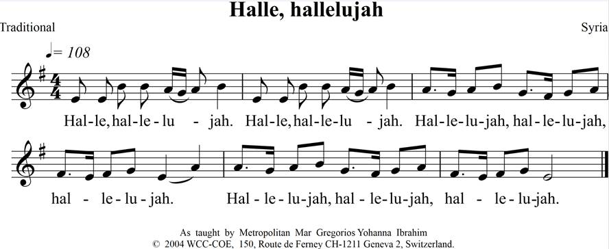

or
Halleluja preiset den Herrn" (BG 1042,1, German and Surinamese)
or
"Hallelujah" (Chorus, ThM 65, Indonesian)
or
"Ich hörte Jesu Wort und Ruf" (BG 1049:1+3; “I heard the voice of Jesus say” in Kiswahili).

Sermon

Instrumental music

Creed
Nicene-Constantinopolitan Creed (ecumenical version)
We believe in one God,
the Father, the Almighty,
maker of heaven and earth,
of all that is, seen and unseen.
We believe in one Lord, Jesus Christ,
the only Son of God,
eternally begotten of the Father,
Light from Light,
true God from true God,
begotten, not made,
of one Being with the Father;
through him all things were made.
For us and for our salvation he came down from heaven;
by the power of the Holy Spirit he became incarnate
from the Virgin Mary
and was made man.
For our sake he was crucified under Pontius Pilate;
he suffered death and was buried;
on the third day he rose again in accordance with the Scriptures;
he ascended into heaven.
He is seated at the right hand of the Father,
he will come again in glory
to judge the living and the dead,
and his kingdom will have no end.
We believe in the Holy Spirit,
the Lord, the giver of life,
who proceeds from the Father;
who with the Father and the Son
is worshiped and glorified;
who has spoken through the Prophets.
We believe in the one holy catholic and apostolic Church.
We acknowledge one baptism for the forgiveness of sins.
We look for the resurrection of the dead,
and the life of the world to come. Amen

Intercessions
After each intercession the congregation responds with "Kyrie, Kyrie eleison!" (GL 156 / EG 178.12 or EG 178.9)

M Loving God, Creator of the whole world!
You created us humans in your image and want to have fellowship with us. You created the whole world and entrusted the earth to us humans to cultivate and preserve it. We thank you for the diversity of your creation and the creativity with which we can shape it.
Give us insight, make us ready to repent – and have mercy on us!

C Kyrie, Kyrie eleison!

M Merciful God!
We can recognise that the world is not in order. We feel that it has gone out of control. We confess that we have turned away from you and elevated ourselves above creation.
Give us insight, make us ready to repent – and have mercy on us!

C Kyrie, Kyrie eleison!

M Holy God!
We pray for the way in which people live together in face of the global pandemic:
may the differences that have emerged in the crisis not lead to division and enmity;
may governments act responsibly and take decisions for the good of all people;
may vaccines be distributed fairly and made available to everyone;
may we all question our values, actions and thinking in the crisis.
Give us insight, make us ready to repent – and have mercy on us!

C Kyrie, Kyrie eleison!

M Eternal God!
We pray for the way in which people to live together in face of racism and discrimination:
may we be open for people who have grown up in other cultures and religions;
may we not make human dignity dependent on outward appearances such as skin colour or gender;
may we not judge people according to their personal attitudes of faith or their political convictions.
Give us insight, make us ready to repent – and have mercy on us!

C Kyrie, Kyrie eleison!

M Almighty God!
We pray for people who suffer from violence inflicted upon them by others, that their suffering may come to an end and that their tormentors may be brought to account. Strengthen their self-confidence so that they do not break down under the violence. Restrain all aggression and acts of war between states and ethnic groups. Make reconciliation possible, and guide our steps on the path of peace.
Give us insight, make us ready to repent – and have mercy on us!

C Kyrie, Kyrie eleison!

M Good God!
We consume and abuse your gifts of creation. We use and plunder the basic resources of future generations. But you hold the suffering world in your hand. In your love you have had mercy on us and on the world. Through Jesus Christ you reconcile us and all creation to yourself. Help us to understand that we are part of your creation.
Give us insight, make us ready to repent – and have mercy on us!

C Kyrie, Kyrie eleison!

M Faithful God!
Hear the groaning of your creation and let us show by our behaviour that we are your children. We pray for all who are suffering from the consequences of environmental destruction. We bring before you all the injustice and poverty, all the hunger and suffering that it brings. We pray for all those who are fleeing because their livelihood has been destroyed.
Give us insight, make us ready to repent – and have mercy on us!

C Kyrie, Kyrie eleison!

Lord’s Prayer
Our Father in heaven,
hallowed be your name,
your kingdom come,
your will be done,
on earth as in heaven.
Give us today our daily bread.
Forgive us our sins
as we forgive those who sin against us.
Lead us not into temptation
but deliver us from evil.
For the kingdom, the power,
and the glory are yours
now and for ever.
Amen.

Announcement of the collection

Hymn "Gott gab uns Atem, damit wir leben" (EG 432, 1-3 / GL 468, 1-3)
or
"Allein Gott in der Höh’ sei Ehr’" (EG 179, 1-3 / GL 170,1-3)
or
"So lang wir Atem holen" (NL 193, 1+3-4)

Symbolic action
A lasting effect should remain after the Ecumenical Day of Creation. In Karlsruhe, trees that are currently damaged are to be replaced by plants that can better withstand the conditions of climate change. Congregations of the local Council of Churches have agreed to be sponsors and are also planting such trees on their own plots of land. Sponsorships like this can also be started in other places. Alternatively, or additionally, it is possible to plant flowers, bushes, herbs or vegetables symbolically during the service.

Blessing

Hymn "Ach bleib mit Deiner Gnade" (EG 347,1-4 / GL 436,1-4)
or
Instrumental music

Further links

Working aids and materials
- Gottes Schöpfung feiern. Ökumenischer Tag der Schöpfung,
published by the Council of Churches in Germany
- www.schoepfungstag.info
- www.ack-nrw.de/publikationen
- www.oikoumene.org/de/node/6282
- www.oikoumene.org/de/what-we-do/care-for-creation-and-climate-justice
- www.oikoumene.org/de/news/webinar-on-season-of-creation-new-rhythms-new-hope
- www.oikoumene.org/de/news/new-film-promotes-orthodox-christian-vision-on-climate-change

Further information
www.schoepfungstag.info
www.ekd.de/agu
www.kath-umwbeltbeauftragte.de
www.emk-gfs.de/
www.nachhaltig-predigen.de
www.wccpilgrimage.org/de
www.oekumene-pilgerweg.de
www.klimapilgern.de
www.kirchen-fuer-klimagerechtigkeit.de

Publisher and distributor
Arbeitsgemeinschaft Christlicher Kirchen in Deutschland /
Council of Churches in Germany
Ludolfusstrasse 2-4
60487 Frankfurt am Main
Germany
Phone +49 69 247027-0
info@ack-oec.de
www.oekumene-ack.de

Preparatory team
Prof. Dr Isa Breitmaier
Peter Bitsch
Rev. Kira Busch-Wagner
Archpriest Abdallah Dis
Prof. Dr Günter Frank
Dr Verena Hammes
PD Reverend Dr Albrecht Haizmann
Dr Marina Kiroudi
Pastor Susanne Labsch
Priest Apostolos Marinopoulos
Archpriest Radu Constantin Miron
Volker Rink
Dean Dr Thomas Schalla
Pastor Daniel Schopf
Pastor Tilmann Sticher
Dean Hubert Streckert
Anna Tanriverdi
OKR Rev. Dr Marc Witzenbacher

The Ecumenical Day of Creation

Christians believe in God, the Creator. They are concerned about the overexploitation of nature. That is why the European churches recommend in the Charta Oecumenica “the introduction in European churches of an Ecumenical Day of Prayer for the Preservation of Creation." The Council of Churches in Germany (ACK) has implemented this recommendation and introduced an Ecumenical Day of Creation. Usually, the nationwide celebration takes place every year on the first Friday in September. The focus is on praise of the Creator, remorse in face of the damage inflicted on creation by humans, and concrete steps to protect it. In local churches, Day of Creation can also be celebrated on another day within the Season of Creation between 1 September and 4 October. This allows them to respect traditions that have already grown up in different places and regions, or to take holiday dates into consideration. The Season of Creation has been celebrated for many years in Switzerland, too, and is also known in Austria.

In Germany, the Year of Ecumenism was proclaimed for 2021/2022 and will conclude with the Assembly of the World Council of Churches 2022 in Karlsruhe. The Ecumenical Day of Creation will be celebrated during the Assembly in international fellowship. It has been jointly prepared by the ACK in Germany, the ACK in Baden-Württemberg and the ACK in Karlsruhe, as well as the coordination office of the WCC 2022 Assembly in Karlsruhe.

This booklet contains the order of service for the Ecumenical Day of Creation 2022 under the motto "God's love reconciles and unites the suffering creation" as a suggestion for your own preparation and implementation of worship services. Congregations are invited to use this material for their service.

Invitation to the central celebration 2023

On 1 September 2023, the central celebration of the Ecumenical Day of Creation will take place in Bremen You are cordially invited to attend! You can find further information under: www.schoepfungstag.info

