Order of Service
for the Ecumenical Day of Prayer for the Care of Creation 2018
“Your fruit comes from me”
The hymns in this service should be thematically appropriate to the motto “Care of Creation” and taken from hymn books used in your churches; wherever possible, they should be familiar to worshippers of various denominations.
Instrumental music for the entrance
Entrance
Hymn
Liturgical greeting
Invocation of the Holy Spirit
spoken alternately by the minister (M) and the congregation (C).
M Through the Holy Spirit the whole creation is renewed and restored to its original state. For the Spirit is of the same power as the Father and the Son.
C Come, Holy Spirit.
M It is proper for the Holy Spirit to rule, to sanctify, to move all creation. For the Spirit is God, of one being with the Father and the Son.
C Come, Holy Spirit.
M In the Holy Spirit dwells all holiness and wisdom. The Spirit calls the whole of creation into existence. We want to serve the Spirit as we serve the Father and the Son, as God.
C Come, Holy Spirit.
M The Holy Spirit is the giver of life. Who gives breath to all life and who is creator together with the Father and the Son.
C Come, Holy Spirit.
M It is the Holy Spirit who instils life into the earth and the heavens. The Spirit is light of light, the great God. Let us worship the Spirit together with the Father and the Son!
C Come, Holy Spirit.
Hymn
Old Testament readings
The Old Testament readings will be spoken from different places in the garden (or the church).
Ezekiel 47:12 (New Revised Standard Version)
On the banks, on both sides of the river, there will grow all kinds of trees for food. Their leaves will not wither nor their fruit fail, but they will bear fresh fruit every month, because the water for them flows from the sanctuary. Their fruit will be for food, and their leaves for healing.
Hosea 14:8
O Ephraim, what have I to do with idols? It is I who answer and look after you. I am like an evergreen cypress; your fruit comes from me.
Ecclesiasticus 11:3
The bee is small among flying creatures, but what it produces is the best of sweet things.
Leviticus 25:19
The land will yield its fruit, and you will eat your fill and live on it securely.
Isaiah 32:15-20
15 A spirit from on high is poured out on us,
and the wilderness becomes a fruitful field,
and the fruitful field is deemed a forest.
16 Then justice will dwell in the wilderness,
and righteousness abide in the fruitful field.
17 The effect of righteousness will be peace,
and the result of righteousness, quietness and trust for ever.
18 My people will abide in a peaceful habitation,
in secure dwellings, and in quiet resting-places.
19 The forest will disappear completely,
and the city will be utterly laid low.
20 Happy will you be who sow beside every stream,
who let the ox and the donkey range freely.
Responsorial Psalm
Psalm 104, spoken alternately
The readers may recite the psalm in different languages.
The congregation responds with the chant “Praise to God the Creator / who gives us His creation, / thanks be to Him for ever!” (sung in English and Greek)
English text of the psalm taken from the Church of England Common Worship
M 1 Bless the Lord, O my soul. / O Lord my God, how excellent is your greatness! / You are clothed with majesty and honour,
2 You are wrapped in light as in a garment. / You spread out the heavens like a curtain
3 You lay the beams of your dwelling place in the waters above. / You make the clouds your chariot / and ride on the wings of the wind.
4 You make the winds your messengers / and flames of fire your servants.
5 You laid the foundations of the earth, / that it never should move at any time.
6 You covered it with the deep like a garment; / the waters stood high above the hills.
7 At your rebuke they fled; / at the voice of your thunder they hastened away.
8 They rose up to the hills and flowed down to the valleys beneath, / to the place which you had appointed for them.
9 You have set them their bounds that they should not pass, / nor turn again to cover the earth.
C Praise to God the Creator / who gives us His creation, / thanks be to Him for ever!
(sung in English and Greek)
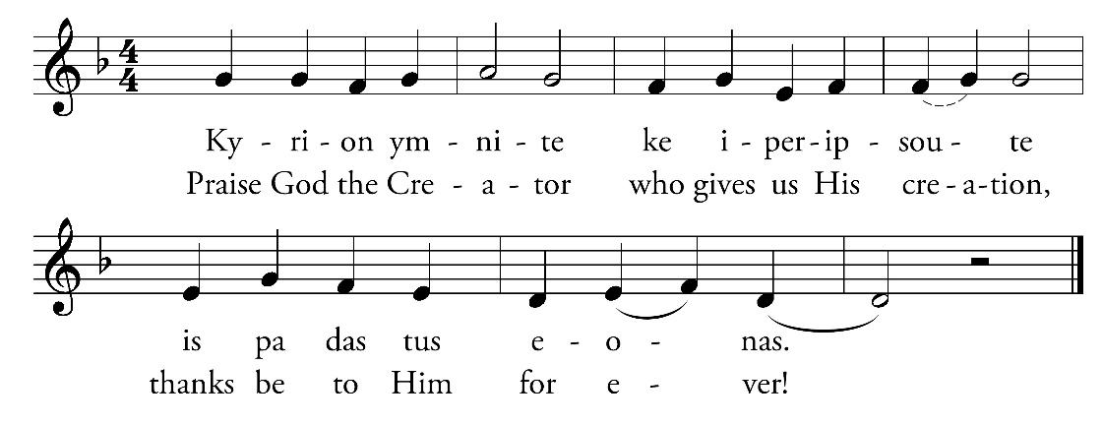
M 10 You send the springs into the brooks, / which run among the hills.
11 They give drink to every beast of the field, / and the wild asses quench their thirst.
12 Beside them the birds of the air make their nests / and sing among the branches.
13 You water the hills from your dwelling on high; / the earth is filled with the fruit of your works.
14 You make grass to grow for the cattle / and plants to meet our needs, / bringing forth food from the earth
15 and wine to gladden our hearts, / oil to give us a cheerful countenance / and bread to strengthen our hearts.
C Praise to God the Creator / who gives us His creation, / thanks be to Him for ever!
(sung in English and Greek)
M 16 The trees of the Lord are full of sap, / the cedars of Lebanon which he planted,
17 In which the birds build their nests, / while the fir trees are a dwelling for the stork.
18 The mountains are a refuge for the wild goats / and the stony cliffs for the conies.
19 You appointed the moon to mark the seasons, / and the sun knows the time for its setting.
20 You make darkness that it may be night, / in which all the beasts of the forest creep forth.
21 The lions roar for their prey / and seek their food from God.
22 The sun rises and they are gone / to lay themselves down in their dens.
23 People go forth to their work / and to their labour until the evening.
C Praise to God the Creator / who gives us His creation, / thanks be to Him for ever!
(sung in English and Greek)
M 24 O Lord, how manifold are your works! / In wisdom you have made them all; / the earth is full of your creatures.
25 There is the sea, spread far and wide, / and there move creatures beyond number, both small and great.
26 There go the ships, and there is that Leviathan / which you have made to play in the deep.
27 All of these look to you / to give them their food in due season.
28 When you give it them, they gather it; / you open your hand and they are filled with good.
29 When you hide your face they are troubled; / when you take away their breath, they die / and return again to the dust.
30 When you send forth your spirit, they are created, / and you renew the face of the earth.
C Praise to God the Creator / who gives us His creation, / thanks be to Him for ever!
(sung in English and Greek)
M 31 May the glory of the Lord endure for ever; / may the Lord rejoice in his works;
32 He looks on the earth and it trembles; / he touches the mountains and they smoke.
33 I will sing to the Lord as long as I live; / I will make music to my God while I have my being.
34 So shall my song please him / while I rejoice in the Lord.
35 Let sinners be consumed out of the earth / and the wicked be no more. / Bless the Lord, O my soul. / Alleluia.
C Praise to God the Creator / who gives us His creation, / thanks be to Him for ever!
(sung in English and Greek)
Hymn
New Testament reading
Gospel according to Matthew 13:31-32 (New Revised Standard Version)
31 He put before them another parable: ‘The kingdom of heaven is like a mustard seed that someone took and sowed in his field;
32 it is the smallest of all the seeds, but when it has grown it is the greatest of shrubs and becomes a tree, so that the birds of the air come and make nests in its branches.’
Hymn
Sermon
Instrumental music
Creed
The Nicene Creed (ecumenical version)
We believe in one God,
the Father, the Almighty,
maker of heaven and earth,
of all that is, seen and unseen.
We believe in one Lord, Jesus Christ,
the only Son of God,
eternally begotten of the Father,
Light from Light,
true God from true God,
begotten, not made,
of one Being with the Father;
through him all things were made.
For us and for our salvation he came down from heaven;
by the power of the Holy Spirit he became incarnate
from the Virgin Mary
and was made man.
For our sake he was crucified under Pontius Pilate;
he suffered death and was buried;
on the third day he rose again in accordance with the Scriptures;
he ascended into heaven.
He is seated at the right hand of the Father,
he will come again in glory
to judge the living and the dead,
and his kingdom will have no end.
We believe in the Holy Spirit,
the Lord, the giver of life,
who proceeds from the Father;
who with the Father and the Son
is worshiped and glorified;
who has spoken through the Prophets.
We believe in the one holy catholic and apostolic Church.
We acknowledge one baptism for the forgiveness of sins.
We look for the resurrection of the dead,
and the life of the world to come. Amen
Intercessions
The congregation (C) responds to each intercession with the sung response
“Hear us, we beseech you, Lord.”
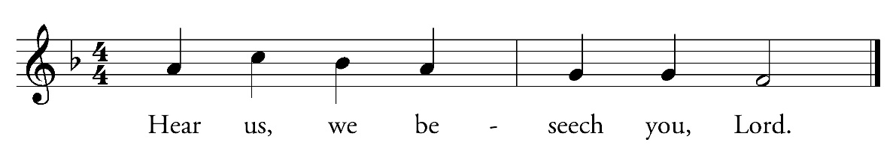
M God, our father,
You have given us the world to be a blessing to us.
Grant us the gift of insight, that we may always perceive this anew.
Hear us, we beseech you.
C Hear us, we beseech you, Lord.
M God, our father,
You have given us the world to be a blessing to us.
Grant us the gift of repentance, that we may turn away from a lifestyle of selfishness and destruction.
Hear us, we beseech you.
C Hear us, we beseech you, Lord.
M God, our father,
You have given us the world to be a blessing to us.
Grant us the gift of hospitality, that we may share it together with all people and bear responsibility for everyone.
Hear us, we beseech you.
C Hear us, we beseech you, Lord.
M God, our father,
You have given us the world to be a blessing to us.
Grant us the gift of moderation, that we may live in it and not exploit its resources ruthlessly.
Hear us, we beseech you.
C Hear us, we beseech you, Lord.
M God, our father,
You have given us the world to be a blessing to us.
Grant us the gift of perseverance, that we may use it sustainably – preserving it for ourselves and all future generations.
Hear us, we beseech you.
C Hear us, we beseech you, Lord.
M God, our father,
You have given us the world to be a blessing to us.
Grant us the gift of joy, that we may serve in it as your stewards.
Hear us, we beseech you.
C Hear us, we beseech you, Lord.
M God, our father,
You have given us the world to be a blessing to us.
Grant us the gift of gratitude, that we may praise you for it every day.
Hear us, we beseech you.
C Hear us, we beseech you, Lord.
M God, our father,
You have given us the world to be a blessing to us,
and through our Lord Jesus Christ you have adopted us as your children.
That is why we can all call you “Father”.
That is the goal of our entire life and all our prayers:
Lord’s Prayer
Our Father in heaven,
hallowed be your name,
your kingdom come,
your will be done,
on earth as in heaven.
Give us today our daily bread.
Forgive us our sins
as we forgive those who sin against us.
Lead us not into temptation
but deliver us from evil.
For the kingdom, the power,
and the glory are yours
now and for ever.
Amen.
Announcement of the collection
The collection should be earmarked for a project which protects the environment.
Hymn
during which the offertory is taken
Symbolic action
Apples and other fruits from the garden and the region are placed in the centre. The minister says a prayer of praise and thanksgiving to the Creator.
M Creator of the heavens and the earth, you have crowned heaven with a host of stars and created the lights in the dome of the sky; you have furnished the earth with fruit for the benefit of mankind; you have created the human race and given them grace to enjoy the splendour and radiance of the stars above and to feed themselves below with the fruits of the earth. We pray to you: send refreshing rain in abundance; let the earth bring forth fruit and yield a rich harvest for the sake of your goodness and loving kindness. Remember those who call upon you, glorify your one, holy, and catholic Church; hear our prayers and supplications and bless the whole earth. This we pray through your only begotten Son, Jesus Christ, to whom be honour and power in the Holy Spirit for ever and ever.
The fruits are distributed to the worshippers.
Hymn
Blessing
Instrumental music
Exit

Copyright: Arbeitsgemeinschaft Christlicher Kirchen in Deutschland e.V. │ Council of Churches in Germany
Ludolfusstraße 2-4
60487 Frankfurt am Main
Germany
Tel.: 0049/69/247027-11
Fax: 0049/69/247027-30
info@ack-oec.de
www.oekumene-ack.de

Or ‚faithfulness‘

